BUILDING PROJECTS’ DURATIONS
To check if the duration in weeks of 50 projects’ proposed and actual time is the same in a building constructing firm.
Proposed Duration (Week) | Actual Duration (Week) | N | Mean Difference
45.7 | 47.8 | 50 | 2.1

The average duration of the proposed and actual are 45.7 and 47.8 respectively and on average, the actual duration was 2.1 weeks higher than the proposed duration, i.e., took 2.1 more weeks to finish a project.
The statistics test and p value is given as;
Statistics test | P-value | Effect size
320 | 0.002 | 0.47

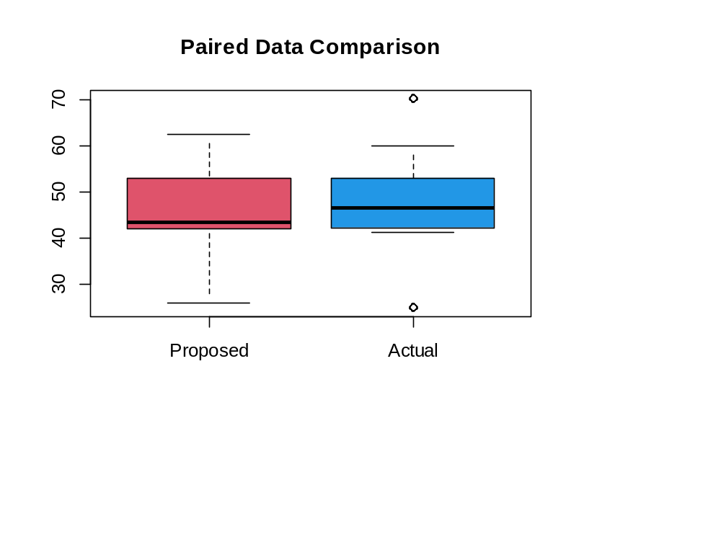
From the result, p<0.05 implies there is statistically difference between proposed and actual duration and the effect size is small, thou, the time to finish a project took more little time than the proposed time.
The graph shows that 50% of the projects took more time to complete the project than the proposed time and there were projects that were completed far below and above other projects.

